Annotated Note Taking

To annotate means to add critical commentary or explanatory notes or to provide explanations for words and phrases within the text. Annotating generally takes place in the margins of text or on a separate piece of paper if you can’t write on the reading.

Why annotate?

Unlike highlighting, which is passive, annotating will help you stay focused and involved with your text. It will also help you to monitor and improve your comprehension. If you come across something you don’t understand or that you need to ask your instructor about, you’ll be able to quickly make note of it and then go on with your reading.

To annotate:

Annotating can be used in many different ways. You’ll want to decide what type you will use based on your purpose for reading and the type of text. Ways to annotate include:

- Underline important terms

- Circle definitions and meanings

- Write key words and definitions in the margins

- Signal where important information can be found with key words or symbols in the margin

- Write short summaries in the margin at the end of sections

- Write questions in the margin next to the section where the answer is found

- Indicate steps in a process by using numbers in the margin

- Describe the usefulness of the information in the margin

- Discuss the limitations of the author’s argument

- Make notes about the reliability of the source

- Make notes about the author’s background, bias, or assumptions

- Summarize conclusions the author presents and evaluate them

- Describe your reaction to the text

- Write connections you make to the text (text to self, text to text, or text to world)

Modified from: Keely, Meg. “Annotated Text.” The Basics of Effective Learning. Bucks County Community College,

Example of Annotated Text:
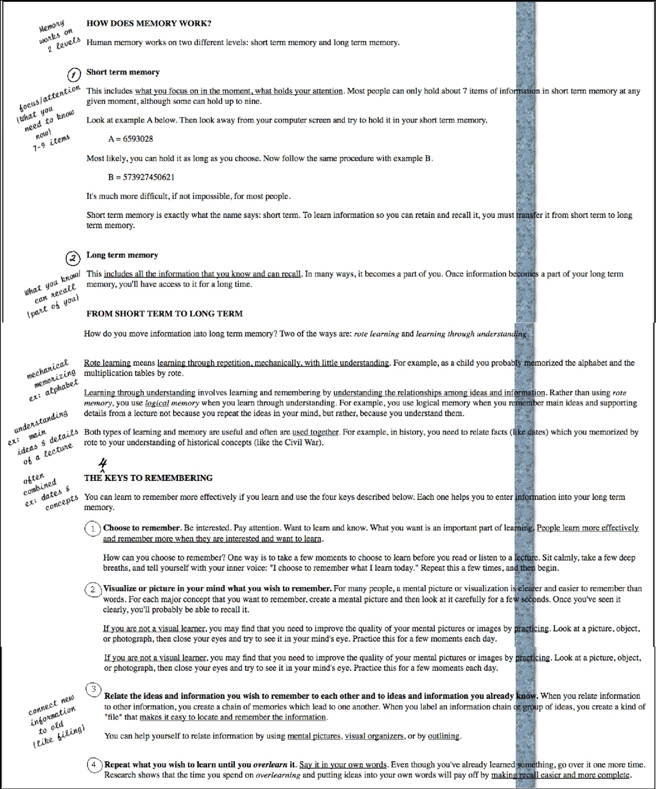

Keely, Meg. “Annotated Text Example.” The Basics of Effective Learning. Bucks County Community College, 1

March 1999. Web. 20 June 2009. <http://www.bucks.edu/~specpop/annotate-ex.htm>.

